Story
Date | 29 August 2026
Team ID
Project Name | India’s Agricultural Crop Production Analysis
Maximum Marks | 5 Marks

By using stories in Tableau, you can effectively communicate complex data in a way that is both interactive and engaging, making it easier for the audience to follow along and understand the insights. It’s a tool for data storytelling, allowing you to present insights in a cohesive, engaging way that take viewers through a logical progression of findings or analyses.
In tableau story is a feature that allows you to create a sequence of dashboards, visualization, and text to present data insights in a cohesive and narrative-driven way. It’s like a slideshow within Tableau that guides the audience through a series of data points, helping them understand key insights, trends or outcomes of analysis.
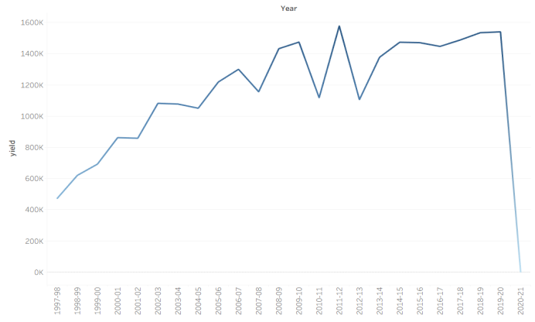
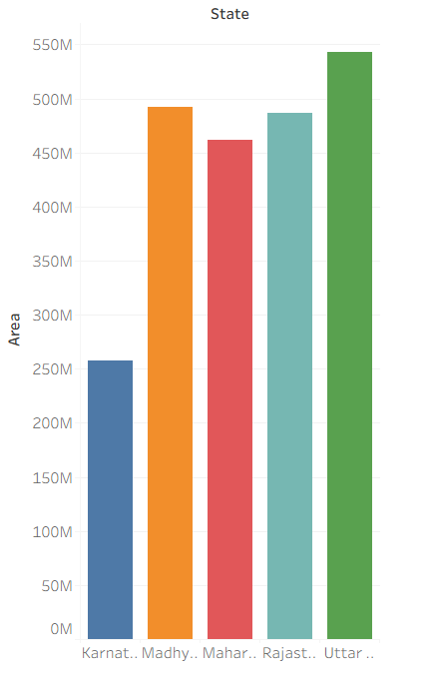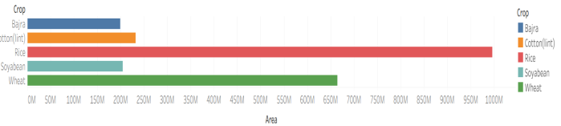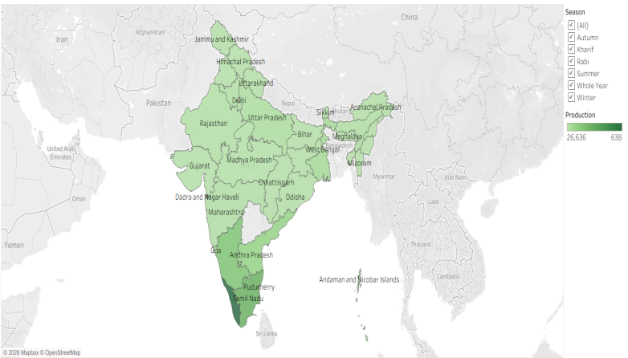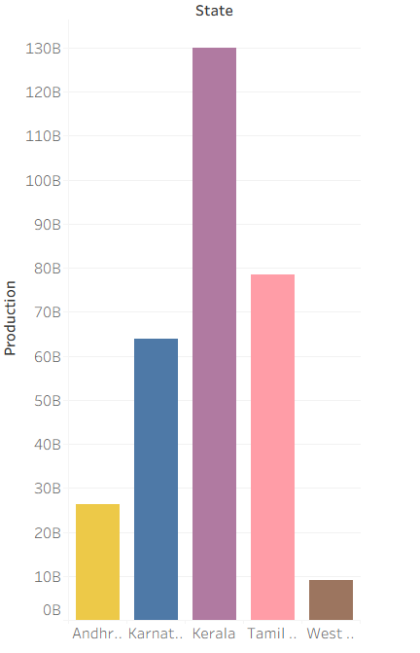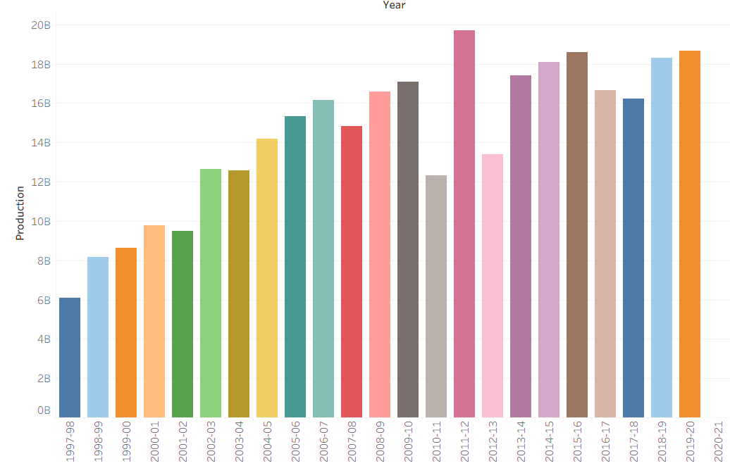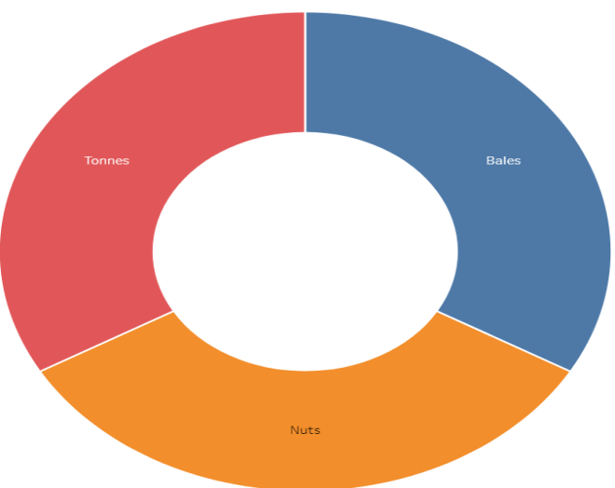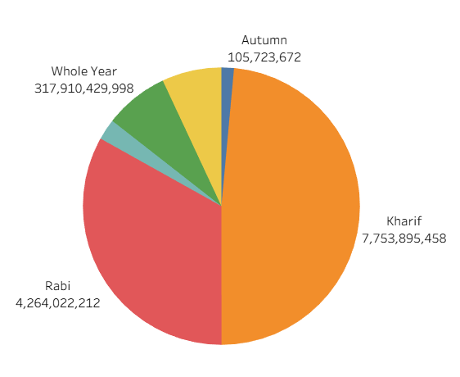
Observation:
- Yield Trend Shows Growth with Fluctuation: The trend of agriculture yield shows a consistent increase from 1997 to 2019, reaching it’s peak around 2018-2019, with a sharp decline in 2020-21 indicating the impact of uncertain conditions on yield.
- State-wise Cultivated Area Leadership: Uttar Pradesh has the highest cultivated area with more than 500M hectares, followed by Madhya Pradesh and Rajasthan with around 470M respectively, while Karnataka has the lowest among the top states.
- Season- wise Production Dominance: Whole year season dominates the total production share with the longest bar, significantly higher than Kharif, Rabi, Autumn and Summer seasons, showing year-round crops are major contributors.
- India Map Insights: The state wise agriculture production map shows that central and northern states like Uttar Pradesh, Madhya Pradesh and Maharashtra have higher production density compared to other regions.

Activity 2:
Publish story on Tableau Public and paste public link below
https://public.tableau.com/views/IndianAgriculturalData_17880613420090/Story1?:language=en-US&publish=yes&:sid=&:redirect=auth&:display_count=n&:origin=viz_share_link

